Fruit and vegetable scraps

[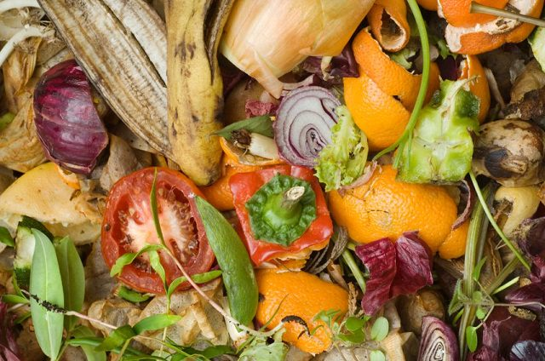](https://balconygardenweb-lhnfx0beomqvnhspx.netdna-ssl.com/wp-content/uploads/2016/06/fruit-and-veggies-crap.jpg)

Although you can simply compost fruit and vegetalbe scraps in compost pile, you can also put them through a food processor and use them around your tomatoes, peppers, and more to feed them. Peppers and tomatoes love this and you can expect a bumper harvest.